This section provides a framework to analyze the corporate diversification decision: a firm trying to enter a new business starting from an existing one. “New” here means new to the firm, not necessarily new to the world. For example, a company that only made footballs may diversify and start producing and selling footwear (see Figure 4.1 for the value chains before and after diversification). In section 1 we defined a business in terms of the “who” (customer), “what” (product or service), and “how” (value chain). Two businesses are different if they differ on at least one of these dimensions. Therefore, diversification implies a new choice on at least one of these dimensions. For example, a bank that traditionally only provided services to businesses starts targeting consumers (who), an accountancy that begins to offer consultancy advice to existing clients (what), or a university that starts selling courses online (how) are all diversifying. Internationalization—a company that begins selling in another country—is an instance of diversification in terms of the “who”, e.g., a French champagne producer exporting to Russian clients.

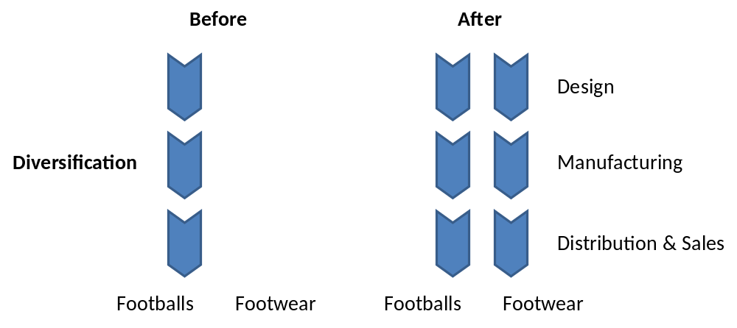
Figure 4.1. Corporate diversification

“Entering” a business implies owning at least some of the resources and capabilities in the value chain underlying the new business, and accessing the rest, possibly through partners. It thus entails the process by which a firm accesses the resources and capabilities necessary to operate in a new business, through ownership and/or partnerships.

Choosing between modes of diversification
The basic modes available for a company to expand into a new business are captured in what we call the “Growth tree” (see Figure 4.2). At the first branch of the growth tree lies the choice between internal and external development. This has also been referred to as organic vs. inorganic growth. Organic growth is the process by which a company enters a new business on its own, including hiring, creation of a new project or business unit, or repurposing an existing business unit. If we think of the new business as possessing its own value chain, the goal of organic growth is to build up the resources and capabilities that this value chain entails on its own, without recourse to other firms.

Under inorganic growth we distinguish among three broad categories: non-equity alliances, equity alliances, and mergers and acquisitions. If a firm allies with another firm, both parties commit resource to joint activity—operate jointly—but remain independent. The relationship can exist without equity (such as a revenue sharing or licensing agreement) or with equity (including joint ventures). If a firm acquires another firm, the target firm ceases to exist and is now part of the acquiring firm (in a merger both firms cease to exist and continue together in a new entity).
The goal for these relationships in the context of diversification (these may be conducted for other reasons) is to access ready-made resources and capabilities relevant to the value chain of the new business. These modes may differ widely in their costs and benefits. Ultimately, we must compare the four alternatives at the bottom of the branches of the growth tree to pick the best one.

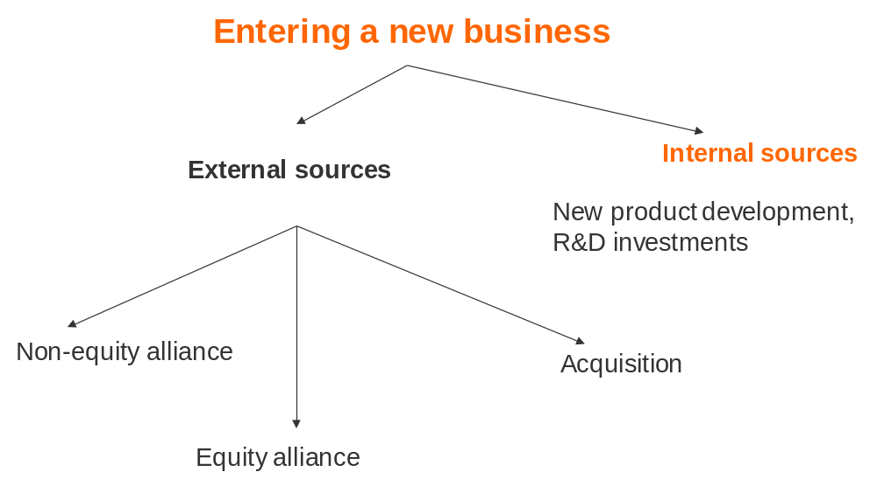
Figure 4.2 Growth tree

The attractiveness of the new business in standalone terms is sometimes seen as the most important factor in the decision to diversify. However, in Section 1 we introduced a basic principle of corporate strategy: that the more mature and efficient the capital markets in which a company operates, the greater the pressure on the company to engage in diversification primarily on the basis of potential synergies between existing and new businesses. Put simply, the CEO should be spending the shareholder’s money on entry into a new business only to extract value that the shareholder could not by investing directly in such a business on her own. Thus synergies from linking operations across the old and new business play a more important role in justifying diversification decisions. Finally, since there are many possible modes of entry into the new business as captured in the growth tree, and the benefits and costs of each mode may be different, we need to think about the cost of entry and benefits created for each mode separately. The diversification test (see Box 4.1) captures the combined effects of these three considerations, namely the standalone attractiveness of the business (relative to cost of entering the business), the importance of synergies, as well as the costs and benefits of entry under different modes.

Box 4.1 The Diversification Test
Let us say your corporate portfolio currently comprises business A, and the question is whether you should also enter business B. The diversification test can be written as:
V_{m}(AB) – C_{m}(B) > V(A)

V(A) is the standalone net present value of business A. V_{m}(AB) is the net present value of jointly operating both business A and B, under diversification mode m. C_{m}(B) is the cost of entering business B through growth mode m. This leads to the following combinations:

Growth mode (m) | Value of jointly operating business A and B (V_{m}(AB)) | Cost of entry (C_{m}(B))
Internal development | Value of A and B when jointly operated and owned, taking into account governance (i.e. ownership) costs | Cost of building resources
Acquisition | Value of A and B when jointly operated and owned taking into account governance (i.e.ownership) costs | Cost of acquiring resources
Equity alliance | Value of A and part of B when jointly operated but only a share of B is owned, taking into account governance (i.e. ownership and transaction costs) | Cost of setting up alliance (including equity stake)
Non-equity alliance | Value of A and part of B when jointly operated but not jointly owned, taking into account governance (i.e. transaction) costs | Cost of setting up alliance

The diversification test is written from the perspective of a focal decision maker, but each side to an alliance or acquisition transaction will conduct their own analysis. Further if the diversification test is passed, it is also consistent with social value maximization. Ideally, you should diversify into the new business that generates the largest difference between the left and right hand sides of the inequality.
An important result for corporate strategists to know is that to pass the diversification test, either bargains or synergies are required. A bargain occurs when you pay less for a business than its standalone value, i.e. C_{m}(B) < V_{m}(B). Under either acquisition or organic growth, you are entitled to 100% of the returns of business B so a bargain occurs at any price less than that. Under an alliance, you are entitled to only part of the returns from B and a bargain is said to occur whenever setting up the alliance costs less than that. The ability to “get a bargain” could arise from private information, an advantage created through regulation or political favor.
If it is unlikely you can “get a bargain” for any of these reasons, then the cost of entry will typically be at least as much as the value of the business (and usually more). In that case diversification can only be justified through synergies. Recall the synergy test: Potential synergies exist whenever jointly operating two businesses can create more value than the sum of their standalone values, i.e. V(AB)>V(A)+V(B). Recall that the synergy test indicates potential value, and does not consider governance costs (which can be seen as a tax eating into the synergies). However, if it is not passed, then there can be no net value from synergies after accounting for governance costs, for any growth mode, m. If synergies can’t be achieved with joint operations free of any governance costs, then they can’t be achieved under any governance structure with their associated governance costs.
Thus if the synergy test fails, then it must also be true that V_{m}(AB) < V(A) + V_{m}(B). Without bargains, as we noted, C_{m}(B) > V_{m}(B). Therefore, if there are no bargains to be had, it is necessary that the synergy test be passed for the diversification test to be passed. Indeed if you get a great bargain, you may even be willing to tolerate some negative synergies. However even if the synergy test is passed, governance costs associated with the mode of governance selected, and the costs of entry for this mode may still be large enough to fail the diversification test. For instance in cross-border contexts, the costs of entry may be higher because of government regulations or lack of information about the true value of assets being purchased. Therefore in the absence of bargains, passing the synergy test is necessary but not sufficient to pass the diversification test.

It also follows that a bargain by itself is neither necessary nor sufficient to diversify: you could diversify because of synergies (even if you have to pay more than the standalone value), and even if you can get a bargain negative synergies may stop you from diversifying. Similarly, synergies by themselves are neither necessary nor sufficient to diversify: if you can get a business for a bargain it might be worthwhile entering even if there are no synergies, or even with strong synergies you may be forced to pay too high a price to enter profitably.

Your best bet is when you can get both a bargain and extract value from synergies net of governance costs. Unfortunately, these clear cut cases are rare, so that the diversification decision must usually rest on a careful comparison of the cost of entry and realized synergies net of governance costs.

A five step approach to the diversification decision
From the diversification test it follows that a decision whether to diversify cannot be decoupled from the decision how to diversify (i.e. choice of growth mode). The growth tree suggests a hierarchical structure to these choices: we can compare within the inorganic growth options and then compare the best inorganic growth option to the organic growth option. In section 5, we will focus on choosing the best inorganic growth mode. In section 6, we will compare the best inorganic growth mode to organic growth. Thus, the diversification decision involves comparing the best external with internal growth mode – If at least one of the options is better than the status quo (i.e. has a positive NPV), you would diversify using the best growth mode. If neither option is better than the status quo (i.e. NPV is zero or negative for both), you would not diversify.

Step I: Are there potential synergies between old and new business?
In order to sharpen our thinking about the synergy test, rather than consider the new business in the abstract, assume your goal is to understand if you can justify paying a premium for acquiring the best performing standalone firm in the new business under the assumption that the cost of implementing the merger is zero. If there are potential synergies, which you may use the 4C’s framework from Section 2 to analyse, the answer will be a “yes” (assuming no costs of implementation is useful, else you could only justify a premium if the synergies are larger than the governance cost). Even if the answer is yes, this does not imply that you should acquire; this is just a test for existence of synergies, which as we have seen above are necessary but not sufficient to justify entry when there are no bargains to be had.

On the other hand if the answer is no, then you must simply ask if a diversification opportunity has arisen that really represents a bargain, and whether the size of the bargain is large enough to cover any negative synergies. If yes, diversify, else do not diversify.

Step II: Identify resource gaps
Assuming that the synergy test is being met, we must next identify the Resource Gaps: what the desired resources or capabilities needed to diversify into a new business are in order to operate in the new business. To do so, we must construct a hypothetical value chain for the new business, and identify the gaps: the resources and capabilities needed to operate in that value chain that we do not currently possess.

Step III: Identify candidates for resource acquisition through inorganic growth
Does any other company already possess the desired resources and capabilities identified as gaps in Step II? If the answer is “No”, then organic growth is the only option, else we need to do a full-fledged Growth Tree analysis (requiring both steps IV and V).

Two caveats are in order before we proceed: First, the choice between modes of growth is often a matter of emphasis rather than all or nothing. Companies diversifying into a new business may often use both organic and inorganic growth, indeed there may be complementarities between the two modes of growth. This is because you may choose to build some of the resources needed to operate in the new business, but buy others. In fact, in our terminology, you need to own some resources to be “in a business”. Thus the growth tree analysis is ideally conducted at the level of individual value chain segments rather than at the level of the entire value chain of the new business. Further, some internal capability is necessary to be able to assess potential partners from whom to buy resources and capabilities, and working with external partners may help direct and stimulate internal growth efforts. At the same time, the circumstances may dictate primary reliance on one of the modes of growth.

Second, regulatory requirements often block attempts by companies to grow purely organically. For instance, in some sectors in the Chinese and Indian economies, Foreign Direct Investment is restricted to constitute no more than (say) 50% ownership in a subsidiary. In such sectors, entry must necessarily be inorganic, and through partnerships.

Step IV: Optimal partner-mode combination for inorganic growth
For each identified potential candidate that can help fill resource gaps inorganically, we must consider different potential growth modes; non-equity alliance, alliance, acquisition. The value from each of these modes for each partner will differ and can be captured in what we call a “Partner-Mode” matrix (details in Section 5). Identify the best combination of partner and mode in this matrix.

Step V: Compare with value from organic growth
We estimate the value of projects that organically build the resources needed to fill the resource gaps identified in Step II, and compare to the value of the best partner-mode combination identified in Step IV. One can also work backwards, and see how much investment and time would be needed to generate an organic growth NPV that matches what we obtained for the best partner-mode combination in Step IV (details in Section 6).

Basic facts about diversification
The basic facts about diversification to emerge from meta-analyses of the existing research relate to three areas:

- Diversification is an important economic phenomenon.
Diversification is how multi-business firms are created. It is the norm among large companies. Diversified companies account for typically more than 50% of national economies, across the globe. The majority of firms in global rankings like the Fortune 500, are diversified multi-business firms, as are the business groups that dominate emerging economies.

- Related diversifiers do better than single-business firms and unrelated diversifiers.
Relatedness is broadly understood to mean the possibility of finding synergies across businesses. This finding holds for both accounting-based measures (e.g., growth, profitability, and ROE) and market-based measures (e.g., stock market returns, and market-to-Document values). Common explanations include that related diversifiers can extracts synergies that are, by definition, absent in single-business firms. In addition, the realization of synergies might be easier for related than unrelated businesses (because of differences in business models). In line with this, M&As between related companies create more value when announced than between unrelated companies (i.e., both the acquirer and target share prices go up more).

- The existence of a diversification discount
Often it is suggested that highly diversified firms trade at a discount. But a discount relative to what? One interpretation is that a diversified firm is worth less than a collection of single-business firms that operate in the same businesses as the diversified firm. The evidence indicates that this is indeed the case: diversified firms tend to have a discount of 10 to 15% relative to a similar portfolio of focused firms. So in this sense, there is a diversification discount. But we cannot interpret this as causal. If the diversified firms differ from the focused firms in respects other than degree of diversification, then we are comparing apples with oranges, and it does not follow that diversification is what caused these firms to suffer a discount. Comparing a diversified firm with itself overtime (when it was more vs. less diversified) or using statistical tests that attempt to account for any difference between diversified and focused firms, the results show that the diversification discount when it exists is less than 10% and in some case disappears completely. Based on these findings, a strategy of diversification is not bad per se. Rather some corporations diversify inappropriately leading to a discount, whereas others diversify without such discount, and possibly with a premium.

To summarize, an overview of the steps involved in the diversification decision:
- Step I: are there synergies to being in new + old businesses?
  - Hint: Could you justify paying a premium for acquiring the best performing standalone firm in the new business? (This is to distinguish the value from improving a standalone business from the synergies between businesses; it’s the latter we are after here).
- Step II: Resource Gap
  - What resources needed for the new business value chain do we already have? What do we lack?
- Step III: Identify best Inorganic Growth candidates who can fill the gap
- Step IV: Identify Combination of Best mode for Best inorganic growth candidates and estimate value from this.
- Step V: Estimate organic growth value, and compare to the result of Step IV.

Steps III and IV are covered in Section 5, Section 6 covers step V.

Mistakes to avoid in diversification

Diversification for the wrong reasons: As we noted in Section 1, diversifying to manage unsystematic risks is only valuable if shareholders cannot do it. As the diversification test in this section makes clear, diversifying into a business just because it is attractive is also a mistake; there have to be synergies between the new and existing business.

Don’t assume a blanket diversification discount – Investment banks and equity analysts often apply a diversification discount (a.k.a. conglomerate or holding company discount). Discounts of 15% are common. We advise against arbitrarily applying such a discount. First, the existence of a discount is questionable once the correct apples-to-apples comparison is done (see above). Second, and perhaps more importantly, the calculation of any discount is about an average discount. As with any average, some diversified firms are above and some below so it may not give a good estimate for your diversified firm. Thus while applying a diversification discount as a bargaining tactic may be ok, this is unlikely to be a good valuation technique.

Consider relatedness is terms of the value chain, not in products or customers – Most of the studies rely on an industry classification, which is based on some similarities in products and/or customers. As we have seen in Section 2, the correct approach to a synergy-based diversification decision is to consider the value chain. Any operational synergies come from linking value chain segments.

Use the growth tree iteratively – Even if organic growth seems limitedly attractive, do not rule it out at the first stage as it might be more attractive than either the ally or acquire option. Consider all branches of the tree.

Frequently asked questions
- In the diversification test, why is the standalone value of B (V(B)) not included on the right hand side?
The standalone value of B (V(B)) does not feature explicitly, but it does so implicitly through the cost of entry (C_{m}(B)). In the absence of bargains, the other side is unwilling to sell business B for less than the money it could generate on a standalone basis. Hence, the synergy and diversification test are closely linked.

- Research has shown that failure rates for alliances, acquisition, and organic growth are high and their magnitude roughly comparable. Can we conclude that a CEO should be indifferent between these options?
No. It would only make sense to be indifferent between these modes of growth if they could be interchangeably applied to the same business situation. This is far from the case. Alliances, acquisitions, and organic growth are alternative means by which a CEO can achieve business growth and they each have different strengths and weaknesses. The apparent similarity of failure rates masks the fact that each mode of growth is usually selected for different kinds of business growth situations; in fact, choosing the inappropriate model of growth may itself be a cause of failure.

- My business is doing poorly. Is this a good enough reason to diversify into a new business?
No. You must still pass the diversification test, which is possible if the costs of bankruptcy are high and the costs of redeploying your current assets into the new business are low.

- Is vertical integration a form of diversification?
Vertical integration may be seen as a particular form of “within business” diversification. For instance, suppose the footwear business shown at the beginning of the section formerly did just design but now enters manufacturing as well (forward integration) or the converse (backward integration). Technically, just the manufacturing of footwear or its design can be seen as a business by itself, since it has its own business model (i.e. distinct answers to the question of who is the customer, what is the value proposition and how is this delivered). Thus the movement to integrate upstream or downstream value chain activities can be conceptualized and analyzed using the same basic tools we use to understand across diversification in general.

Academic background
For more on growth modes, see:
Capron, L., & Mitchell, W. (2012). Build, borrow, or buy: Solving the growth dilemma. Boston, USA: Harvard Business Press.

For meta-analyses of the empirical literature on diversification, see:
Capon, N., Farley, J. U., & Hoenig, S. (1990). Determinants of financial performance: A meta-analysis. Management Science, 36(10), 1143-1159.
Datta, D. K., Pinches, G. E., & Narayanan, V. K. (1992). Factors influencing wealth creation from mergers and acquisitions: A meta- analysis. Strategic Management Journal, 13(1), 67-84.
Palich, L. E., Cardinal, L. B., & Miller, C. C. (2000). Curvilinearity in the diversification–performance linkage: An examination of over three decades of research. Strategic Management Journal, 21(2), 155-174.

For estimates of the diversification discount taking into account firm differences, see:
Campa, J. M., & Kedia, S. (2002). Explaining the diversification discount. Journal of Finance, 57(4), 1731-1762.
Villalonga, B. (2004). Does diversification cause the ‘diversification discount’? Financial Management, 33(2), 5–27.

For further reading on the costs of diversification, see:
Rawley, E. (2010). Diversification, coordination costs, and organizational rigidity: Evidence from microdata. Strategic Management Journal, 31(8), 873-981.
Wu, B. (2013). Opportunity costs, industry dynamics, and corporate diversification: Evidence from the cardiovascular medical device industry, 1976-2004. Strategic Management Journal, 34(11), 1256-1287.
Zhou, Y. M. (2011). Synergy, coordination costs, and diversification choices. Strategic Management Journal, 32(6), 624-639.

